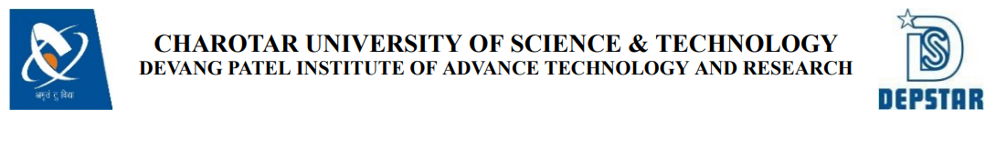

**Weekly Report**

In this report students require to mention the work has been done during the week and planning for the next week. (Please fill individual report for each week)

|  |  |
| --- | --- |
| **Student ID: 20DCE051** | **Student Name: Dipak Karmur** |
| **From Date: 10/5/2022** | **To Date: 15/5/2022** |
| **Semester: 5th** | **Internship ID:** |

**Work done in last week (Attach supporting Documents):**

In first week of Internship I learned and revised some basic concepts of ReactJS. I learned basic concepts like props, components, routing etc. and I referred official documentation of React for explore concepts of ReactJS. I revised some concepts of advanced javascript also.

**Plans for next week:**

In next week I will try to get familiar with ReactJS concepts like hooks and state management. I will try to build real world project to learn the concept very well.

**References:**

1. [www.youtube.com](http://www.youtube.com)

2. [www.reactjs.org/docs](http://www.reactjs.org/docs)

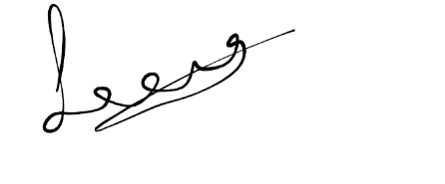

Signature of External Guide Signature of Internal Guide



**Weekly Report**

In this report students require to mention the work has been done during the week and planning for the next week. (Please fill individual report for each week)

|  |  |
| --- | --- |
| **Student ID: 20DCE051** | **Student Name: Dipak Karmur** |
| **From Date: 16/5/2022** | **To Date: 22/5/2022** |
| **Semester: 5th** | **Internship ID:** |

**Work done in last week (Attach supporting Documents):**

In second week of Internship I builded weather app to learn some concepts of hooks like usestate, useeffect and learned how to fetch data from API and how to handle it. I also used concepts like routing for better understand it. Afterwards, I started my internship project ‘Movieseries App’. in which I try to cover all concepts of ReactJs.

In second week I made front page and interface of app .Front page is Trending page. it contains all trending movies and series of week. I used API of The Movie DB (TMDB) website. Below the content of Trending page I implemented pagination component from material ui which contains 10 pages of trending movies and series.

**Plans for next week:**

In next week I will try to make two other pages Movies and Series and also implement pagination and genre type components.

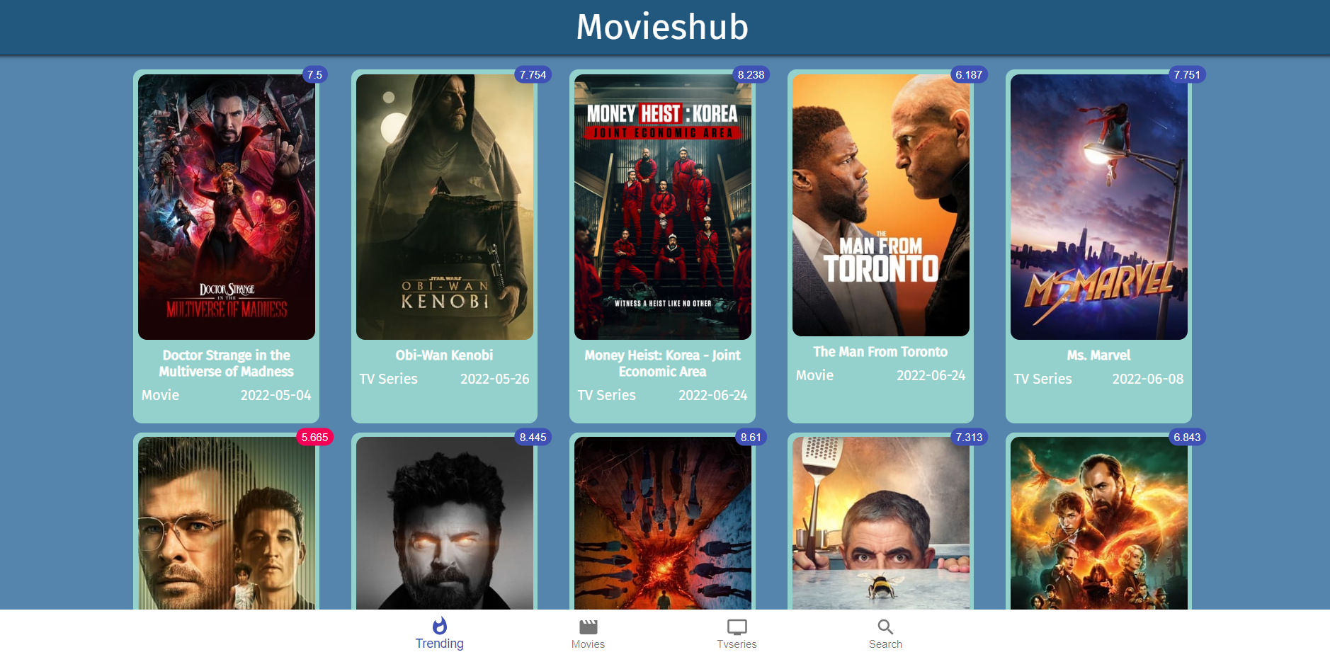

**References:**

1. [www.youtube.com](http://www.youtube.com)

2. [www.reactjs.org/docs](http://www.reactjs.org/docs)

3. <https://mui.com/material-ui>

4. https://www.themoviedb.org



Signature of External Guide Signature of Internal Guide



**Weekly Report**

In this report students require to mention the work has been done during the week and planning for the next week. (Please fill individual report for each week)

|  |  |
| --- | --- |
| **Student ID: 20DCE051** | **Student Name: Dipak Karmur** |
| **From Date: 23/5/2022** | **To Date: 30/5/2022** |
| **Semester: 5th** | **Internship ID:** |

**Work done in last week (Attach supporting Documents):**

In Third week of Internship I continued Movieseries app and implemented more things. Using Genre component of Material ui. I implemented filter to types of content like action, drama etc. I set one type as a default in both the pages. I also added pagination component in both the pages which show maximum number of pages of content.

**Plans for next week:**

In next week I will try to make one more page which is search page and also try to implement modal which is pop up by clicking on card content of app. In modal it will show details of movie or series and also provide link to watch trailer of the same.

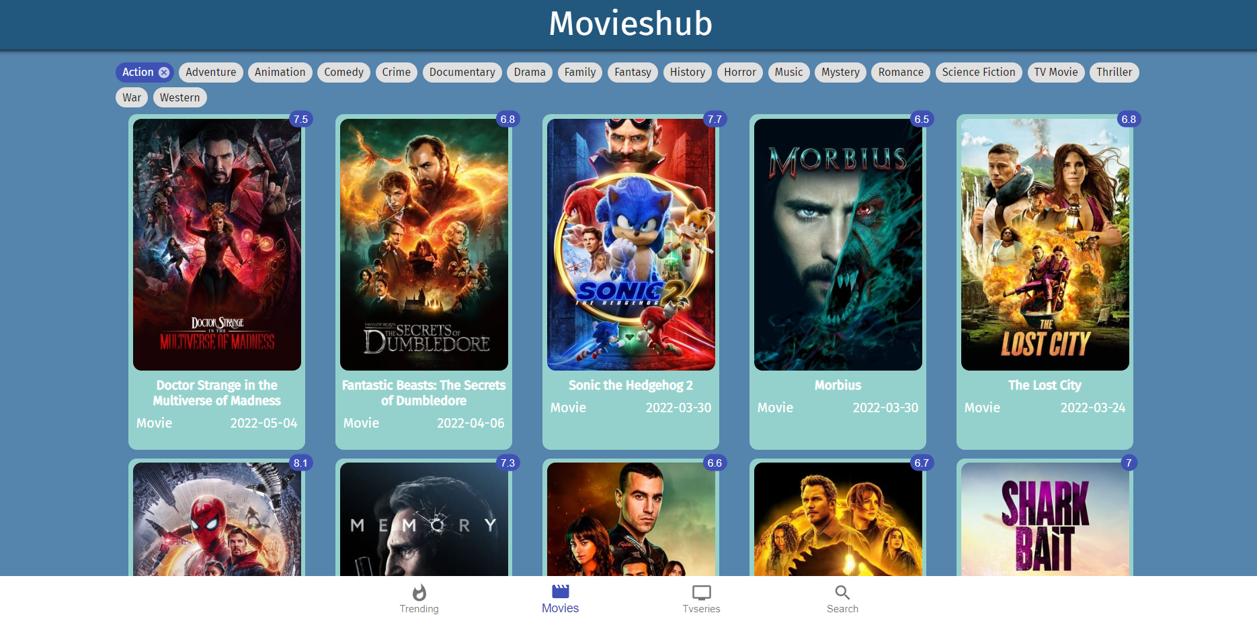

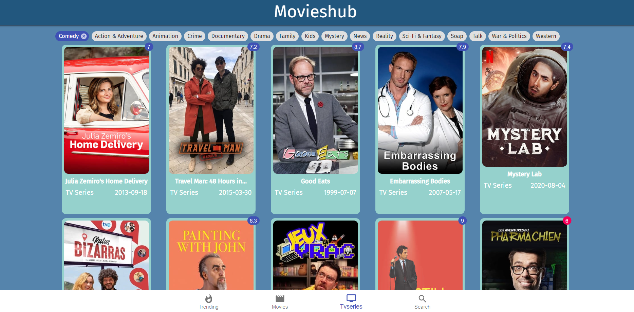

**References:**

1. [www.youtube.com](http://www.youtube.com)

2. [www.reactjs.org/docs](http://www.reactjs.org/docs)

3. <https://mui.com/material-ui>

 4. <https://www.themoviedb.org>

Signature of External Guide Signature of Internal Guide



**Weekly Report**

In this report students require to mention the work has been done during the week and planning for the next week. (Please fill individual report for each week)

|  |  |
| --- | --- |
| **Student ID: 20DCE051** | **Student Name: Dipak Karmur** |
| **From Date: 31/5/2022** | **To Date: 6/6/2022** |
| **Semester: 5th** | **Internship ID:** |

**Work done in last week (Attach supporting Documents):**

In Fourth week of Internship I made last page of app which is search page in which user can search any movie or series and I also made modal which provide details about particular movie or series. Pagination component was also implemented in search page which is according to content, show maximum number of pages in search page.

In the modal I displayed title, description, poster, caste-crew images and youtube link. By using carousel library from npm package i displayed name and images of crew-caste of movie or series.

Finally, I completed my whole project in last week and I uploaded in github repository and also deployed in netlify.

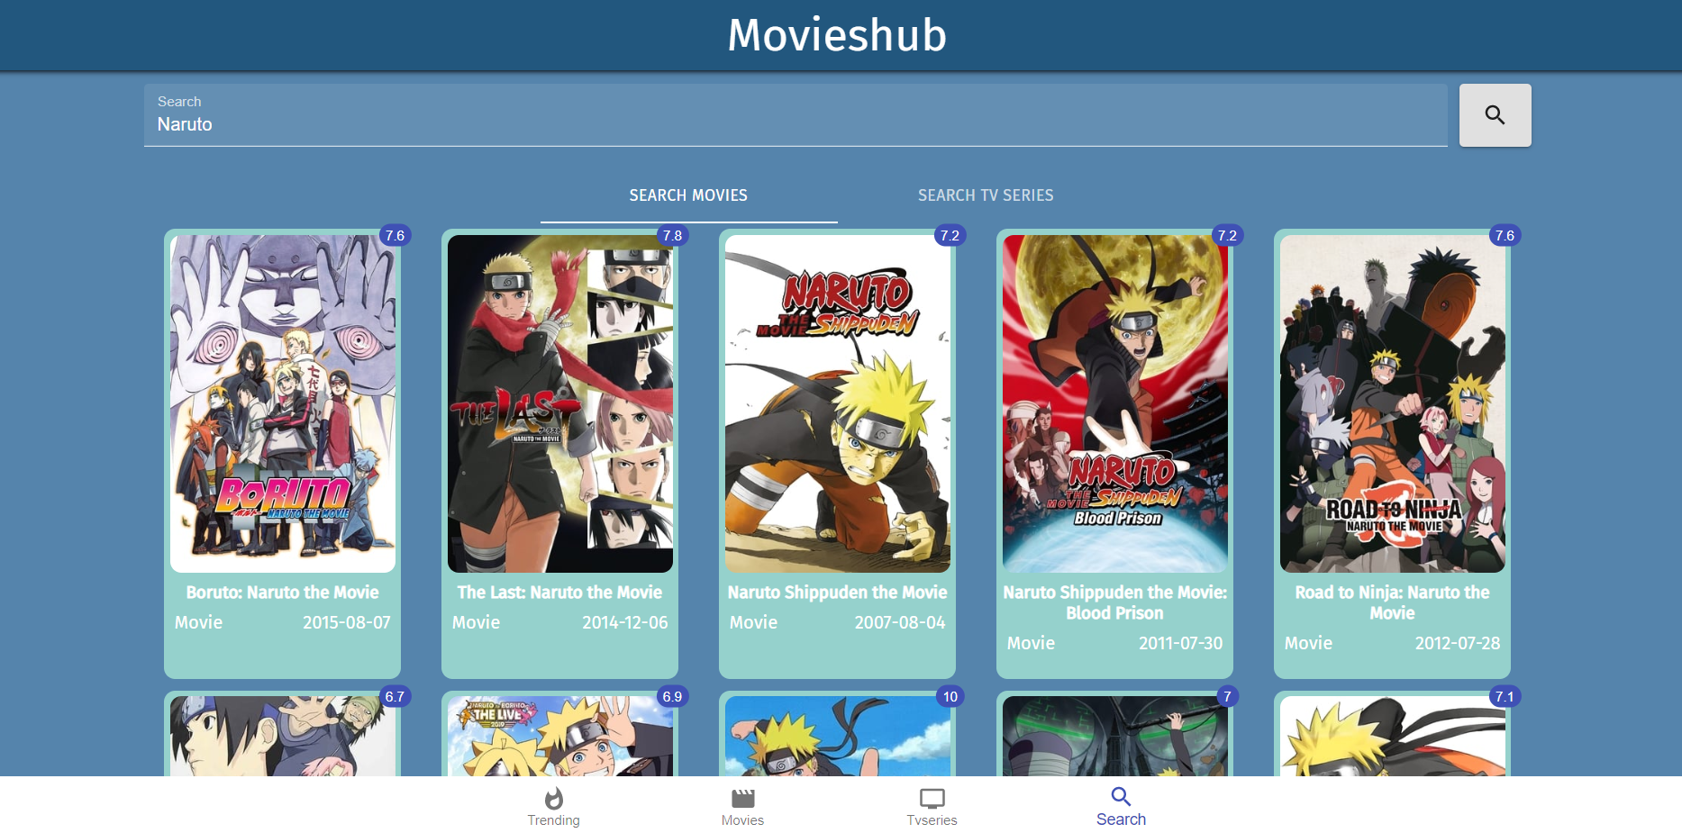

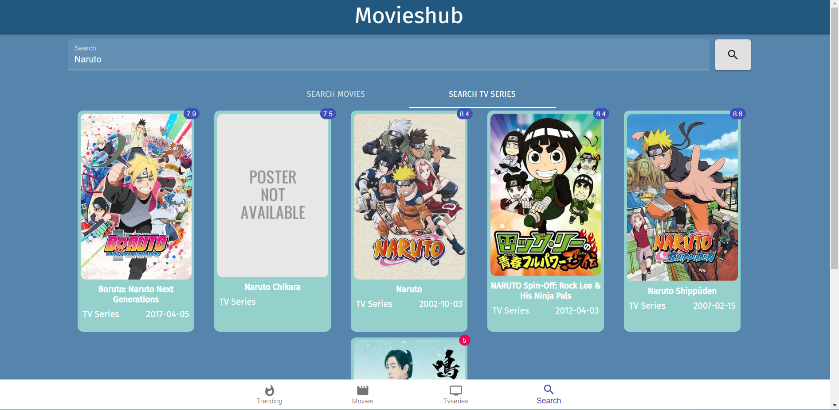

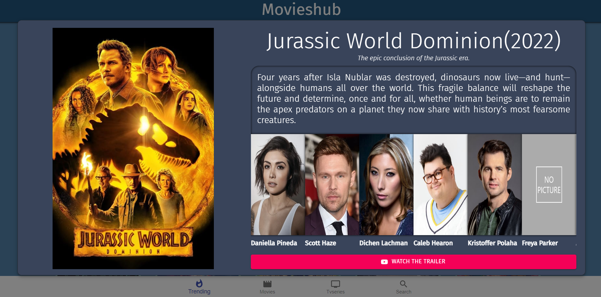

**References:**

1. https://www.youtube.com/c/RoadsideCoder

2. [www.reactjs.org/docs](http://www.reactjs.org/docs)

3. <https://mui.com/material-ui>

4. https://www.themoviedb.org

5. <https://www.npmjs.com/package/carousel>



Signature of External Guide Signature of Internal Guide